**Reflection /Reflective learning**

Reflection is a way of processing ideas that have no simple solution. In an academic context reflection is for a stated purpose. Moon (1999) likens reflection on learning to ‘*mental housekeeping’*

Try to think about something from your learning this year which has challenged you. Describe in one or two sentences what it was.

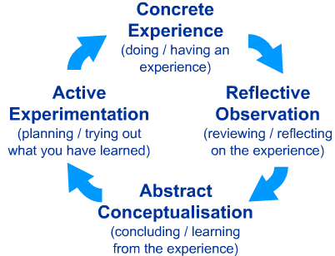

|  |  |
| --- | --- |
| **Reflective questions** | **Responses** |
| Who supported your learning? | The people in the group and Andy Brown the course leader. |
| What factors enabled you to learn? | The course power points and activities |
| What have you remembered most from this experience? | That project management is complex |
| What has this challenge enabled you to do now? | This challenge has given me the knowledge to think about various aspects of project management |
| What did you do next? | To use the experience that I have learned and apply it in School |
| What have you learned about yourself from this experience? | That I need to think about goals and objectives |

**Editing**

It is very important in reflective writing that you take time to edit your writing and make sure it is as concise as possible. Cut out as much description as possible.